



ENGLISH FOR SCIENCE AND TECHNOLOGY

**L2 S3 2022-2023**





# Course description

This course is tailored for undergraduate students majoring in science and technology studies. The primary focus of this course is to improve students' English skills so as to prepare them to write and communicate effectively within their scientific communities.

Throughout the semester, we will focus on the analysis of different types of documents (written and oral) to enable students to learn how to read scientific literature more efficiently, and encourage them to use English to discuss scientific topics with their peers.

Learning English is of paramount importance for science students’ careers as English is the international language of science. Whether you are applying for a job, keeping up with recent scientific breakthroughs, or communicating with other people, being proficient in English will always come in handy.

All the course materials needed to follow the lessons will be made available online. **Students are kindly asked to print all in-class materials.**

# Learning outcomes

Upon completion of the course, students will be able to...

* Write and communicate effectively within their scientific communities.
* Understand and analyse scientific documents (either written, audio or video).
* Expand their scientific vocabulary linked to their field of study.
* Deepen their understanding of current environmental and ethical issues.
* Autonomously study and keep up to date with recent scientific breakthroughs

# Teaching staff

**Jean-Thomas COLOMAS** [jean.colomas@u-pec.fr](mailto:jean.colomas@u-pec.fr)

**(course leader)**

Nedim BUYUKYUKSEL

Catherine KORPAL Cécile LORIN Maia PEYRE

Karin PY Bréhima SIDIBE Andreea STROIE

Maria TURGIEVA

**Offices**: P3 005 & P3 006



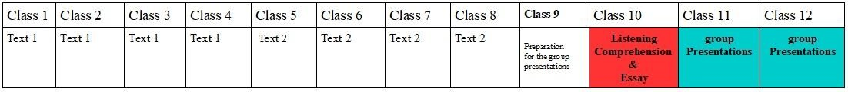

# Assessment and course organisation

Your final grade will be made up as follows:

* + **1 group presentation**: see page 19 for more details. 25%
  + **1 Listening comprehension test** followed by **an essay**. 25%
  + **1 Final Exam**: Vocabulary/comprehension questions based on a new text, a short essay and vocabulary/grammar questions based on the content of this course. 50%

If you fail to achieve the pass mark (10 out of 20 after compensations) for this semester’s course, **a Make-up test** is scheduled at the end of the school year. The grade obtained at the make-up exam will replace your final grade if superior to the original grade.

**Course attendance is mandatory and participation is essential to student success**.

If you are not able to attend a test due to an emergency or unavoidable conflict (illness or injury, family emergency, court order etc.) please reach out to your teacher and submit the appropriate documentation.

The University of Paris-Est Créteil places a high value on academic integrity and has a policy on plagiarism, cheating and other academic offences:

#### Règlement intérieur de l’Université Paris-Est Créteil Val de Marne

**Article 26** : Usage des moyens de communication L’usage des moyens de communication, transmission et réception ne doit pas porter atteinte au fonctionnement de l’Université. Sauf autorisation expresse de l’enseignant responsable, le téléphone portable ou tout autre moyen de communication, transmission et réception sont interdits pendant tout examen, concours et plus largement toute situation d’évaluation. L’usage de ces moyens ne doit pas porter atteinte au fonctionnement de l’Université.

**Article 27** : Plagiat Conformément au Code de la propriété intellectuelle, le plagiat défini comme toute représentation ou reproduction intégrale ou partielle d’une œuvre de l’esprit sans le consentement de son auteur est illicite. Les travaux universitaires doivent revêtir un caractère personnel, ce qui exclut tout plagiat y compris à partir de documents issus de sites Internet. Néanmoins, sont permises les courtes citations si le nom de l’auteur et la source dont elles sont tirées sont clairement indiqués. Le plagiat défini au premier alinéa peut donner lieu à une sanction disciplinaire indépendante de la mise en œuvre de poursuites pénales.

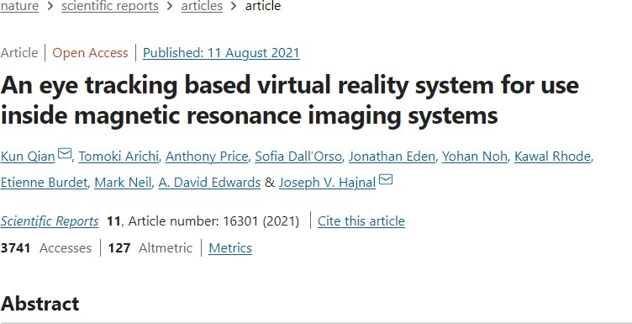



Patients undergoing Magnetic Resonance Imaging (MRI) often experience anxiety and sometimes distress prior to and during scanning. Here a full MRI compatible virtual reality (VR) system is described and tested with the aim of creating a radically different experience. Potential benefits could

5 accrue from the strong sense of immersion that can be created with VR, which could create sense experiences designed to avoid the perception of being enclosed and could also provide new modes of diversion and interaction that could make even lengthy MRI examinations much less challenging. Most current VR systems rely on head mounted displays combined with head motion

10 tracking to achieve and maintain a visceral sense of a tangible virtual world, but this technology and approach encourages physical motion, which would be unacceptable and could be physically incompatible for MRI. The proposed VR system uses gaze tracking to control and interact with a virtual world. MRI compatible cameras are used to allow real time eye tracking and robust gaze

15 tracking is achieved through an adaptive calibration strategy in which each

successive VR interaction initiated by the subject updates the gaze estimation model. A dedicated VR framework has been developed including a rich virtual world and gaze-controlled game content. To aid in achieving immersive experiences physical sensations, including noise, vibration and proprioception

20 associated with patient table movements, have been made congruent with the presented virtual scene. A live video link allows subject-carer interaction,

projecting a supportive presence into the virtual world.

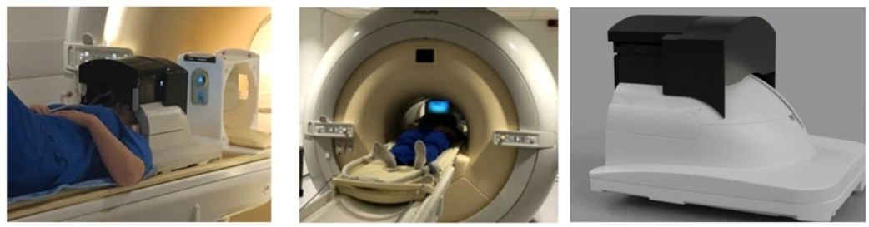

The microscopic assessment of tissue samples is instrumental for the diagnosis and staging of cancer, and thus guides therapy. However, these assessments demonstrate considerable variability and many regions of the 25 world lack access to trained pathologists. Though artificial intelligence (AI) promises to improve the access and quality of healthcare, the costs of image digitization in pathology and difficulties in deploying AI solutions remain as barriers to real-world use. Here we propose a cost-effective solution: the augmented reality microscope (ARM). The ARM overlays AI-based 30 information onto the current view of the sample in real time, enabling seamless

integration of AI into routine workflows. We demonstrate the utility of ARM in the detection of metastatic breast cancer and the identification of prostate cancer, with latency compatible with real-time use. We anticipate that the ARM

will remove barriers towards the use of AI designed to improve the accuracy 35

and efficiency of cancer diagnosis.

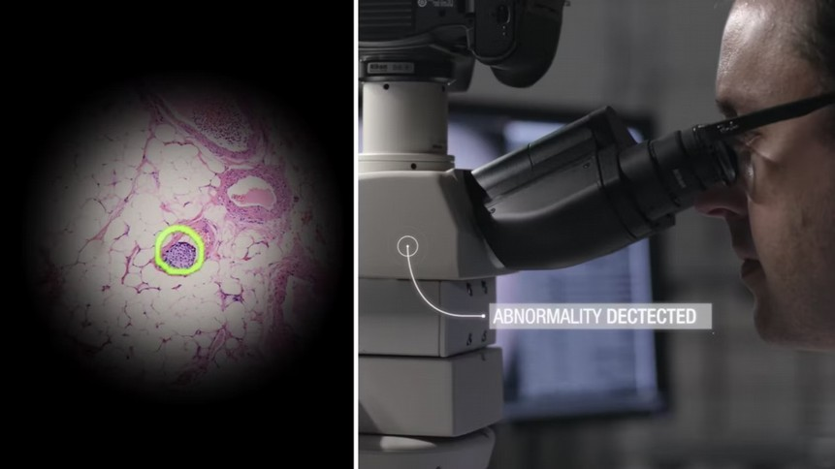

4

# Vocabulary

#### Match each word 1-10 with one synonym from the box below:

|  |  |  |  |
| --- | --- | --- | --- |
| ~~make better~~ ~~superimposes~~ focus on | expect | replaces | ~~don't have~~ hope |
| ~~offer~~ ~~permit~~ ~~experiencing~~ | ~~depend~~ ~~on~~ | ~~result~~ | grow allowing |

|  |  |  |
| --- | --- | --- |
| 1. undergoing (l.1) experiencing = subir |  | 6. lack (l.26) don’t have |
| 2. accrue (l.5) result |  | 7. improve (l.27) make better |
| 3. provide (l.7) offer  ISP : Internet Service Provider |  | 8. overlays (l.30) superimposes = superposer |
| 4. rely on (l.9) depend on |  | 9. enabling (l.31) allowing = gave the capacity to |
| 5. allow=like now (l.14) permit |  | 10. anticipate (l.34) |
| **II) Tick the word closest in meaning:** |  | expect |
| 1. prior to/ai/ (l.2): □ after □ due to □ before 2. lengthy (l.8): □ important □ scary □ long |  |  |
| 3. challenging (l.8): □ provocative □ difficult | □ boring |  |

1. current (l.9): □ contemporary □ actual □ widespread actually: in fact, in reality / actual : real
2. congruent (l.20): □ similar □ respectful □ realistic
3. assessment (l.23): □ evaluation □ activity □ judgement
4. accuracy (l.35): □ success □ precision □ fidelity

# Pronunciation

1. **Circle the stressed syllable:** magnetic developed detection achieved assessment supportive

**-**ic -ical – ically -ion : stress is always 1 syllable before the ending

1. **/i/ or /ai/?** MR**I/ai/** anx**i**ety/ai/ pr**i**or to/ai/ v**i**bration/ai/ prom**i**ses/i/ m**i**croscope/ai/ d**i**agnosis/ai/
2. V**R is the same sound as in air her are** all**ow is the same sound as in** n**ow** g**o** sh**ow** v**i**rtual **is the same sound as in** m**i**rror p**ea**rl **a**ssess

# Comprehension

#### Explain or reformulate in English the underlined segments:

“A live video link allows **subject-carer interaction**” (ll.21-22)

It allows a way to communicate between the patient and the one supervising the MRI

“The microscopic assessment of **tissue samples** is instrumental for the diagnosis” (ll.23-24)

A small part of a group of cells (un échantillon )

“The microscopic assessment of tissue samples **is instrumental** for the diagnosis” (ll.23-24)

Is mandatory (obligatoir) , is fundamental , useful// needed , very important

“Here we propose **a cost-effective** solution” (l.29)

Solution rentable = cheap solution ( that doesn’t cost a lot)

#### True or false? Circle the correct answer and justify by quoting from the text.

Patients can move their head during the MRI to explore the virtual world. (1) True / False (line 8)

They use eyes-tracking cameras to allow you to move int the V world

This new VR system allows patients to play popular video games. (1) True / False (line 17.)

…………………………………………………………………………………………………………………

The Augmented-Reality Microscope can process information very quickly. (2) True / False (line 34)

…………………………………………………………………………………………………………………

#### Answer the following questions:

1. What is the purpose of these two devices?
2. Focus on just one document of your choice. Imagine you are pitching the invention to a com- pany, and sum up in your own words how the device works. Try to be convincing and enthusiastic!
3. Look at both documents. What do you think is “an abstract”? Identify the different parts.

It’s a part of a scientific report / an abstract = is a summary of a scientific article

1. Explain the difference between Virtual Reality and Augmented Reality. Which one is in your opinion the most promising technology?

# Grammar

**IX) Review time:**

1. Do we say “a” or “an” MRI examination”? Explain why.
2. What does “12k Accesses” mean? (Text 2)

4) Identify the subjects, the verbs, and the objects in these two sentences. Explain the tense of the verbs.

(Practice reading the two sentences out loud!)

* “Patients undergoing Magnetic Resonance Imaging (MRI) often experience anxiety and sometimes distress.”
* “The microscopic assessment of tissue samples is instrumental for the diagnosis and staging of cancer.”

#### Link words

“...and **thus** guides therapy” (l.24) “**However**, these assessments demonstrate...” (l.24) “**Though** AI promises to improve...” (l.26)

Link words are used to connect ideas and express various notions such as: consequence, addition, nuance… Using these words makes your writing much clearer for your reader.

#### Give a synonym for each example above in bold. Can you translate them into French?

|  |  |  |
| --- | --- | --- |
| **Thus** | Synonym(s):this way, so , therefor | French translation: ainsi,donc |
| **However,** | but | Cependant |
| **Though** | Although / even if | Bien que / meme si |

**Insert the right link word from the box below**

in addition, unless, therefore, although, despite, however

1 -He tells everybody he is the boss; HOWEVER , he is just an employee.

1. (malgré, bien que )DESPITE being promoted, he will not get a higher salary.
2. The hit and run driver will have to pay a fine; IN ADDITION , his license will be can-

celled.

1. The dam's water level is critical; , we’ll have to save water as much as we can.
2. ALTHOUGH (meme si ) he was extremely intelligent, he had trouble explaining his ideas.
3. “Nothing will end war (à moins que)UNLESS the people refuse to go to war.” — Albert Einstein.

#### The active and passive voice

**Compare the two following sentences taken from the texts and turn them into the other voice:**

* “A dedicated VR framework has been developed” (l.16)

→ They have developed a dedicated VR framework

* “The ARM overlays AI-based information onto the current view of the sample in real time” (l.30)

→ AI-based information is overlayed onto the current view of the sample in real time

#### How do you form the passive voice? Why is it common in scientific texts?

**Read the two texts again and say whether the verbs are in the active or passive form. In your opinion, which text conveys the results in the most direct and clear fashion?**

# Expression - Speaking task

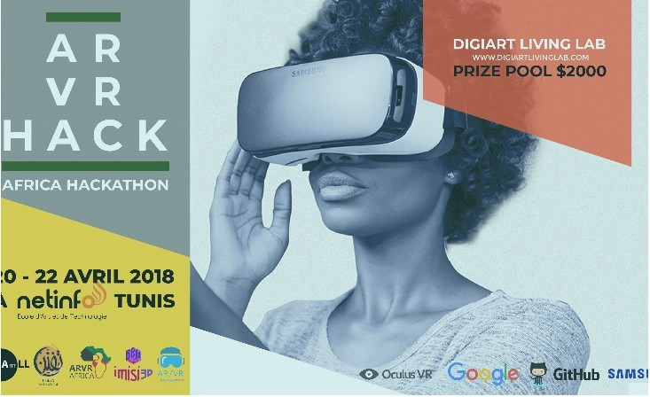

A hackathon is traditionally a live event where people with a technical background create teams around a particular challenge or idea and compete to provide a unique solution.

The aim of this "competition" is to challenge university students to use their creativity to come up with innovative solutions to real-world issues using AR or VR technology.

**In small groups, students have to prepare a 1-minute presentation to showcase an innovative project/idea that uses AR or VR. Students are allowed to present actual projects, or they can come up with their own ideas.**

**Listening Comprehension – The possibilities of Virtual Reality technology – BBC News**

[**https://www.youtube.com/watch?v=J7gONjpamBo**](https://www.youtube.com/watch?v=J7gONjpamBo)

**Part I: Watch the video and write down all the key words that you can hear.** (verbs, stressed words, numbers, dates, proper nouns…)

Fake snow

Everest – vr the last tow years – south London – vr help to get out from the phobia , she was proud and th VR helped her

Immersive experience / people suffering from phobias ( of lifts )

Museum /

#### Part II: Answer the following questions.

1. Where is the journalist? What is he doing?

He was in a freezing cellar (basement) with a fake snow playing a VR game in which he was climbing the mount Everest

Inching(inch: a unit of measurement) across a crevasse (he ‘s crossing a crevasse very slowly)

1. When will the game be released? What is said about the recent evolution of this technology?

It will be released later this year . VR has come a long way in the last few years. It has improved quite a lot

1. What is the purpose of this technology?

lock out every external stimulus so that you are focus on what is displayed in front of you, hence allowing you to be immersed in VR

1. Who are these kids and where are they?

These kids are patients at King’s college hospital in south London

1. What are they doing? How?

They are experiencing the VR for the first time using cardboard-made headsets. They are <virtually> visiting a museum

Visiting the gallery not physically but in VR

1. What are some scientists working on using this technology?

They have developed a program that allows people to get over//overcome their phobia of lifts/elevators

Helping people to get over their phobia

1. How anxious is Helena?

7 out of 10

1. What are the potential symptoms that can arise during this virtual experience?

Heart beating faster / breathing changes / and sweating

1. Has it worked for Helena? How does she feel?

Obviously it worked since she got into a lift

Yes and she was proud

**Part III: Voice your opinion regarding the use of VR in healthcare.**

### Listening Comprehension – Explaining Glasses That Display Captions – CNN 10

[**https://www.youtube.com/watch?v=Rl07mN8aQc4**](https://www.youtube.com/watch?v=Rl07mN8aQc4)

#### Part I: Fill in the blanks with the missing words.

Here we are at one of the UK's : The National Theater. But if you're , all that may mean nothing to you... But you guys are trying to change that.

Over the last two years, we've been developing a new system is called smart caption glasses...

I just want to put them on because I've tried virtual reality, augmented, mixed reality and they're usually heavy. These though are ! I suppose the only difficulty I might feel is the fact that you've got the foreground and the and they're

far from each other so i kind of have to look down and look up at the

.

if you tap the keypad you can change the way it's . You can alter the size, you can alter the positioning on the screen... And people love to have it in pink over the face of the performance so that they can lip read at the same time as reading the captions.

#### Part II: Answer the following questions.

1. What is "augmented reality" according to the journalist?
2. What can be said about the use of these glasses in the National Theater?
3. Explain in detail how accurate these glasses are.

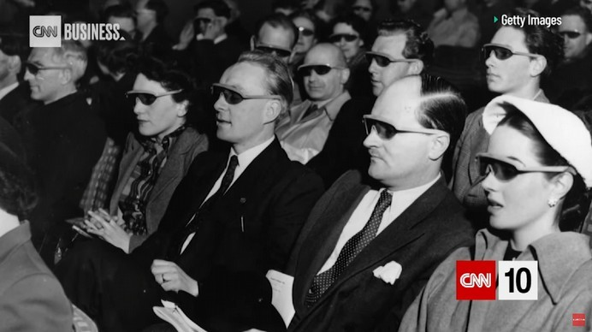

1. Describe the following picture:
2. What does the National Theatre plan to do in the future?
3. What do people think about these glasses?

**Part III: React! Do you think smart glasses will one day be ubiquitous?**

**Text 1: Additional activities 2eme Td**

**Oral interaction practice (15 mins)**

**A**

Ask your classmate to choose a number between 1 and 9, and then read them the corresponding question. They have a minute to give their opinion. You are allowed to weigh in on what your partner says! You must each give your opinion on at least 5 different topics.

|  |  |  |
| --- | --- | --- |
| **1.**  Do you think virtual reality can be dangerous? | **2.**  Would you accept living a year in virtual reality for $50,000? | **3.**  Can VR be useful in education? |
| **4.**  Would you rather pay $1,000 for smart glasses, or get them for free with ads displayed every hour? | **5.**  Do you think we can cure any disease we want thanks to technology? | **6.**  Can Artificial intelligence be better than a human being? |
| **7.**  Do you think video games make people violent? | **8.**  Are you scared of hospitals? | **9.**  Do you think it should be mandatory to use our real identity on the Internet? |

- - - - - - - - - - - - - - - - - - - - - - - - - - - - - - - - - - - - - - - - - - - - - - - - - - - - - - - - - - - - - - - - - - -- -

**Oral interaction practice (15 mins)**

**B**

Ask your classmate to choose a number between 1 and 9, and then read them the corresponding question. They have a minute to give their opinion. You are allowed to weigh in on what your partner says! You must each give your opinion on at least 5 different topics.

|  |  |  |
| --- | --- | --- |
| **1.**  Do you think virtual reality could help people get past their phobias? | **2.**  Would you describe yourself as an anxious person? | **3.**  Do you think one day people will work from home using virtual reality headsets? |
| **4.**  Would you rather live a perfect life in virtual reality or live in the real world? | **5.**  Do you believe virtual travel will one day replace actual holidays? | **6.**  Will everyone wear augmented reality glasses one day? |
| **7.**  Could you live without technology? | **8.**  How can Augmented reality make life easier? | **9.**  Do you think it would be a good idea to see everyone's profile displayed on your smart glasses? |

**II) Describe both pictures in detail. What do you think is happening? Give your opinion. (10 mins)**

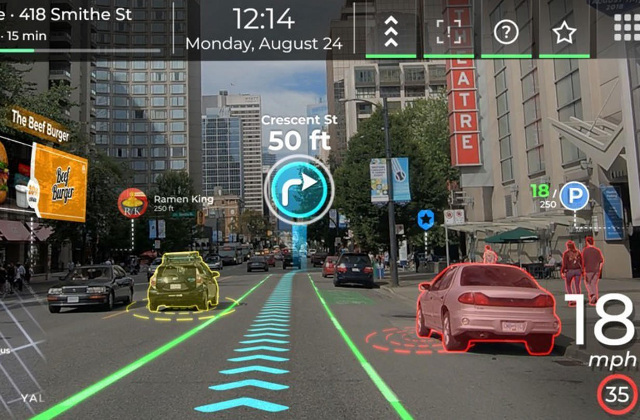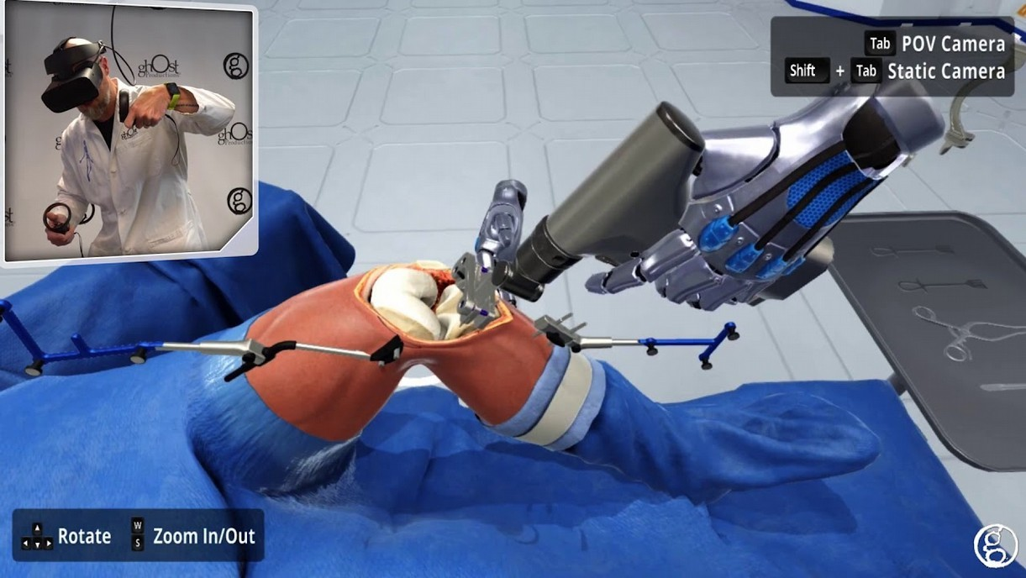

These Shade Balls Were Supposed to Save Water, But There's a Big Problem – Science Alert

<https://www.sciencealert.com/la-reservoir-shade-balls-manufacture-use-more-water-than-they-saved>

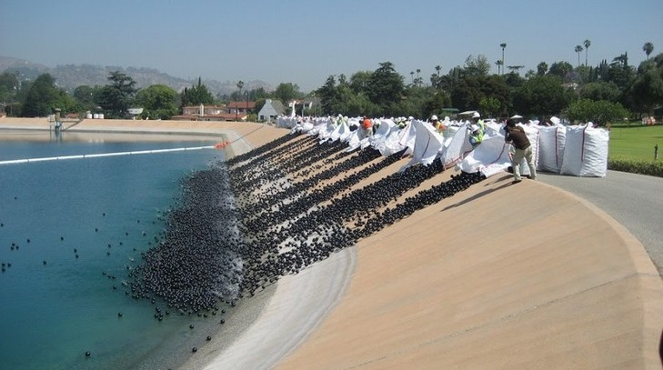

In 2015, 96 million floating plastic 'shade' balls were dumped into the reservoir of drought-embattled Los Angeles. It was a plan to save water by preventing evaporation - and it did - but there was one big wet elephant in the room that was somehow overlooked.

Manufacturing that many plastic balls actually used more water than it saved.

5 According to calculations made by researchers from Imperial College London in the UK, MIT in the US and the University of Twente in the Netherlands, the oil, natural gas and electricity used in the manufacture of the plastic balls would have used around 2.9 million cubic metres of water. The balls were deployed on the reservoir from August 2015 to March 2017. During that time, they prevented around 1.71 million cubic meters from evaporating.

10 Because the scheme saved water in one place by using more water elsewhere, it could have envi/ai/ronmental impacts that weren't considered during the original planning phase. According to the researchers, this is a problem engineers sometimes fall prey to. "We are very good at quick technological fixes, but we often overlook the long-term and secondary impacts of our solutions," said environmental scientist Kaveh Madani of Imperial College London. "This is how the engineering community has been solving problems; solving

15 one problem somewhere and creating a new problem elsewhere."

In order to 'break even' on water usage, the team predicted that the balls would have to be deployed for 2.5 years if they prevented evaporation at the same rate that occurred during the drought conditions. And that's without considering effects on water temperature and bacterial growth and the impact that would have on the aquatic life that lives in the reservoir - concerns that were also raised in 2015.

20 So it's not quite the genius idea we - and many others - thought it was back in 2015, but that doesn't mean it's a total waste of time and resources, either. The shade balls have a lifespan of 10 years (they were deployed for about 15 percent of that time), and are made of recyclable plastic, so they can go on to be reused for other purposes. Shade balls have also been deployed in other reservoirs, most notably the Silver Lake Reservoirs in Los Angeles in 2008, to help prevent carcinogenic/ça donne le cancer/ pollution. They are also used by mining operations to

25 prevent birds from landing on toxic tailing ponds, and by airports to deter birds from landing on drainage ponds, and risking collisions with planes.

And in the end, there's always something to be learned from such engineering experiments. Even a so-called 'failed' experiment is incredibly valuable for knowledge acquisition. Research such as this shows that, even when solutions are implemented in a hurry, science can help us see and learn from our mistakes - and can

30 help engineers to recognise and plan for such problems in the future. "We are not suggesting that shade balls

are bad and must not be used," Madani said. "We are just highlighting the fact that the environmental cost of shade balls must be considered together with their benefits."

The team's research has been published in the journal [*Nature Sustainability*](https://www.nature.com/articles/s41893-018-0092-2).

# Vocabulary

#### Match each word 1-10 with one synonym from the box below:

|  |  |  |  |  |
| --- | --- | --- | --- | --- |
| gotten rid of | stopped | dropped | took place | discourage |
| drawing attention to | protect | developing | dealing with | brought up |
| disregard | warned | conserve | increased | taken into account |

* 1. save (title) conserve 6. prevented (l.17) stopped to prevent : empecher
  2. dumped (l.1) dropped 7. occurred (l.17) took place
  3. considered (l.11) taken into account 8. raised (l.19) brought up (mentioned)
  4. overlook (l.13) disregard 9. deter (l.25) discourage
  5. solving (l.14) dealing with 10. highlighting (l.31) drawing attention to

#### Tick the word closest in meaning.

1. actually (l.4): □ currently □ right now □ in fact
2. fixes (l.12): □ solutions □ repairs □ issues
3. quite (l.20): □ considerably □ calm □ really
4. valuable (l.28): □ effective □ important □ worth a lot of money

#### Give your own synonym:

1. **s**cheme (l.10): …………… 2. concerns (l.19): …………… 3. purposes (l.23): ……………

#### Decompose and guess the meaning of the following words:

1. drought (l.1): …………… 2. landing (l.25): …………… 3. incredibly (l.28): …………...

# Pronunciation

1. **Circle the stressed syllable:** according electricity pollution temperature carcinogenic percent
2. **/i/ or /ai/?** env**i**ronmental eng**i**neers M**I**T **i**dea sc**i**entist m**i**ning recogn**i**se

|  |  |  |  |  |
| --- | --- | --- | --- | --- |
| **VII)** alg**ae** | **is the same sound as in** | s**ee** | gr**ey** | f**a**t |
| dump**ed** | **is the same sound as in** | deploy**ed** | predict**ed** | publish**ed** |
| ga**s** | **is the same sound as in** | ca**s**ual | rai**s**e | fa**c**e |

# Comprehension

##### Explain or reformulate (in English) the underlined segments:

“shade balls were dumped into the reservoir of drought-embattled Los Angeles.” (l.1):

→ ……………………………….…………………………………………………………………………… “but there was one big wet elephant in the room that was somehow overlooked.” (ll.2-3):

→ …………………………...………………………………………………………………………………

“According to the researchers, this is a problem engineers sometimes fall prey to.” (ll.11-12)

→ …………………………...……………………………………………………………………………… “In order to 'break even' on water usage, [...] the balls would have to be deployed for 2.5 years” (l.16)

→ ……………………………………………………………………………………………………………

##### Answer the following questions:

1. What is the purpose of shade balls?

"*We are very good at quick technological fixes, but we often overlook the long-term and secondary impacts of our solutions*" (l.13)

1. Explain the quote mentioned above. Why are shade balls referred to as "quick technological fixes"?
2. What are the potential "long-term and secondary impacts" of shade balls?
3. **True or False? Justify with a quotation from the text.**

Some people were worried about the impact of shade balls. T □ F □ line … According to the researchers behind this study, the shade balls should be deployed for two and a half year so as to offset the amount of water used to produce them. T □ F □ line … Initially, the author had mixed feelings about shade balls. T □ F □ line …

The team that carried out the research is strongly against shade balls. T □ F □ line …

# Grammar

**XI) Review time:**

1. How do you say “2.5 years” “in 2015” and “1.71 million” out loud?
2. Why do we say “ 96 million” and not “~~96 millions~~”? (l.1)
3. What does “According to” mean? (l.5)
4. Reformulate the underlined segment: “**The team's research** has been published in the journal”
5. Translate the following sentences into French:

* “Even a so-called 'failed' experiment is incredibly valuable for knowledge acquisition.”

→

* “So it's not quite the genius idea we - and many others - thought it was back in 2015, but that doesn't mean it's a total waste of time and resources, either..”

→

#### XII) The Present Perfect and The Past Simple

“In 2015, 96 million floating plastic 'shade' balls were dumped into the reservoir” “This is how the engineering community has been solving problems” “The team's research has been published in the journal Nature” “Concerns that were also raised in 2015”

How do we form the Present Perfect? What about the Past Simple?

Justify the use of the Present Perfect tense and the Past Simple in the sentences above. Among the following time markers tick those that are used with the Present Perfect.

□ ago □ since □ last year □ already □ until □ now □ ever □ yesterday □ recently □ so far

#### Complete the questions and the answers (answer either with “for” or “since”):

1. How long (you/work)? 2 hours.
2. How long (she/drive)? last night.
3. How long (they/run)? this morning.
4. How long (he/speak)? too long.

#### Translate the following sentences into English:

1. Nous ne sommes pas retournés sur la lune depuis les années soixante-dix.

→

1. Aucun être humain n’a marché sur Mars à ce jour, mais cela a été fait sur la lune entre 1969 et 1972.

→

1. Avez-vous déjà entendu parler de l’existence d’une ville engloutie au large de l’Inde?

→

1. J’ai lu un excellent article hier sur les futures pénuries d'eau à venir.

→

# Expression – Writing task

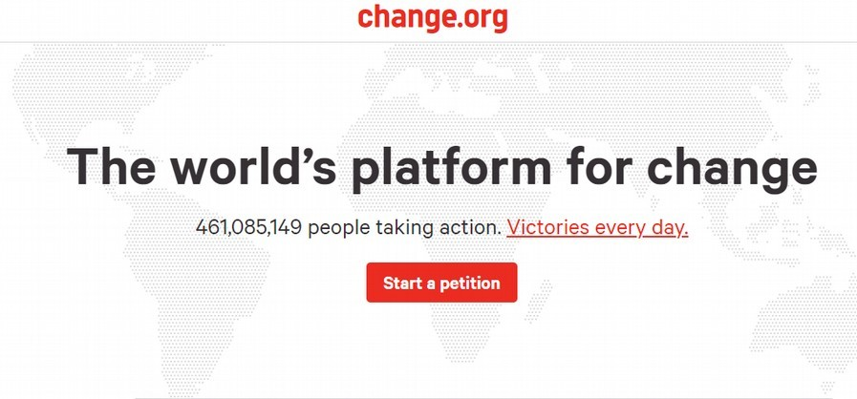

According to a UN report, 5 billion people could be affected by water shortages by 2050. Write a petition ur- ging the government to implement a water conservation plan and lay out some of your ideas.

(Around +-150 words)

#### Listening Comprehension -- Cape Town's Water Crisis Approaches Day Zero

<https://youtu.be/jQQT9ZjmeTA>

#### Part I: Fill in the blanks with the missing words: (0:00 – 2:00)

You only need to look at Theewaterskloof to realize how serious Cape Town's water crisis is. After three years of the city's biggest reservoir has become a

. The dams supplying water to four million people are at . This year, Cape Town's been on the verge of becoming the first major city to water. But, incredibly it's managed to more than the of water it uses. I wanted to find out how. To visitors, life in this stunning city still seems pretty normal. But for those who call Cape Town home, things may never be the same...

#### Part II: Answer the following questions: (2:01 – 5:20)

1. What happened in February?
2. What do some people in Cape Town say regarding tap water?
3. How much water are they allowed to use? How much water does the average Australian consume?
4. Why isn't the toilet filling up? Explain in detail.
5. How much water did they use last month? What is their objective for next month?
6. What has been the hardest thing to get used to for Ruth Hall and David Dunton?

#### Part III: Summarise Ruth Hall's unbelievable experience at work and her viewpoint about the water crisis. (5:21 – 7:08)

**Part IV: React to Ruth Hall's experience at work. Do you think it's an effective water conservation strategy?**

**Text 2: Additional activities**

1. **Solve the following crossword puzzle. You may look up the words in the text! (optional homework)**

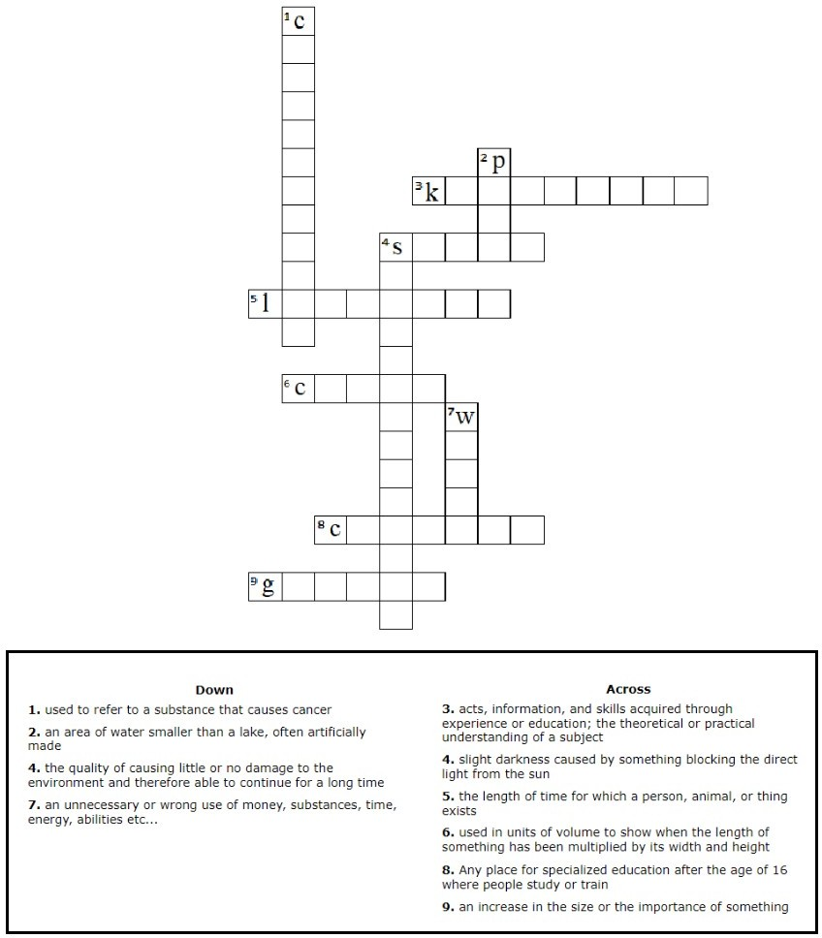

1. **Oral activity: short presentation of a science video (1 hour)**



Students have to form 6 groups and prepare a 2-3 minute presentation on a science video selected randomly.

* + Step 1: Choose a video and watch it a couple of times
  + Step 2: Select a screenshot taken from the video you’ll use as a backdrop to your presentation
  + Step 3: Come up with a good intro/catchphrase (something that will catch your audience’s attention)
  + Step 4: Do some background research on the subject
  + Step 5: Summarise the video
  + Step 6: Give your opinion
  + Step 7: Present the video in front of the whole class!

Once a presentation is over, the audience is invited to briefly summarise in French what they've heard and understood.

Choose a video among the links below: (First come, first served!)

**Theme: Water crises in the world**

**Video 1: (0:00 – 3:16)**

<https://tinyurl.com/UPECvideo1>

**Video 2: (0:00 – 3:32)**

<https://tinyurl.com/UPECvideo2>

**Video 3:**

<https://tinyurl.com/UPECvideo3>

**Video 4:**

<https://tinyurl.com/UPECvideo4>

**Video 5:**

<https://tinyurl.com/UPECVIDEO5>

**Video 6**

<https://tinyurl.com/UPECvideo6>

## Oral group presentation of a science video

#### I-Objectives

The main purpose of this exercise is to assess the presenter's ability to give a clear, well-structured presentation in English of a science video.

Being able to undertake an oral presentation is a valuable skill for your future career. This skill can be developed and honed by **everyone** and is not reserved to those who are "naturally gifted" speakers: hard work pays off!

In addition, the oral presentation assesses students’ capacity to research, arrange and present information in a clear, coherent and effective way.

Following their presentation, students will have to answer questions from the audience. The ability to ask relevant questions will also be assessed.

Below is a list of popular science Youtube channels: (you are free to find other sources)

Nature video, Science magazine, Veritasium, Kurzgesagt, National Geographic, Verge Science, Scientific American, Ted-Ed, SmarterEveryDay, SciShow, It's Okay to Be Smart, Real Engineering, Science Insider, NASA, Vox, Tom Scott, ... And obviously videos from news websites such as BBC News, The New Scientist, The Guardian, The New York Times, NBC News ...

**II-Preparing for your oral presentation**

You must choose a video that pertains to science. This will allow you to further your knowledge and keep up to date with scientific breakthroughs, along with improving your vocabulary and pronunciation of words related to science.

Students must highlight the most important findings of the video.

THIS IS A GROUP PRESENTATION. (in groups of two or three students) Duration: +- **2-3 mins / person**

Powerpoint is **not required**.

You may show a short excerpt of the video before your presentation, display screenshots taken from the video you've chosen, or give your presentation whilst the video is running. (without sound)

Bear in mind that your audience has just one chance to hear your talk; they won't be able to "re- read" your words if they get lost along the way. Hence you should focus on being clear and organised.

AVOID READING DIRECTLY OFF OF YOUR NOTES.

**Three main parts are expected**:

1. **Introduction of the video and the topic (date, nature of the document, title, main topic)**

In this part, you must capture your listeners' attention (you may start with a question, or an amusing story, a provocative statement, basically anything that will engage your audience), then state the purpose of your presentation, and finally give an outline of your talk. (first, I will talk about ... Then ... Finally ...)

#### The Body of your presentation: the main ideas.

In this part, you must present and summarise the main ideas of the video. You may want to pause at the end of each point, and to use transitions so as to allow your audience to be prepared for your next point. You can also use visual aids to make your presentation more appealing and interesting. (e.g. a short video, a picture, a map; a chart

etc...) Your presentation must be clear for every listener, therefore you must define the technical vocabulary if need be.

#### Discussion and conclusion

In the last part of your presentation, you must discuss the main topic and the video. You have to give your opinion, tell your audience why you chose this video/topic, and say what you've learned. Finally, you need to leave your audience with a clear and brief summary of everything that you have covered. (focus on the main takeaways, on the one sentence you want everyone to remember) Watch out: it is paramount that you make it obvious that you have reached the end of your presentation! You must thank the audience, and invite questions.

#### Communication

An oral presentation is much more than just reading a paper or a set of slides to an audience. The way you deliver your presentation is at least as important in effectively conveying your message as the content of your presentation.

You must pay attention to the pronunciation of key words. <https://dictionary.cambridge.org/> <https://www.wordreference.com/fr/>

<https://fr.youglish.com/>

Here are some expressions that you might find useful:

#### Welcoming your audience:

Thank you for coming today. I’m [name] and I’m looking forward to talking with you today about [your topic]. I’m honored to be here

I’m going to talk about / address …

On behalf of [name of company], I’d like to welcome you today.

#### Capturing their attention

Did you know that [insert an interesting fact or shocking statement]? Have you ever heard that [insert interesting fact or shocking statement]?

#### Identifying your goal or topic of presentation

Today I’d like to discuss, I’d like to share with you …

During my talk this morning/afternoon, I’ll provide you with some background on [main topic] and why it is important to you.

I’d like to take this opportunity to talk about… The aim of my presentation is to …

The issue at stake here is … (l’enjeu, ce qui est en jeu)

First of all, First and foremost… The purpose of this presentation is…

#### How to outline your presentation

My talk this morning is divided into [number] main sections… First, I will focus on … second, third… Finally…

First, I’m going to present… Then I’ll share with you… Finally, I’ll analyse… Let me outline the different parts of my talk

Here is a brief outline of my presentation

#### Emphasizing the main points:

It should be emphasized that… Another significant point is that… I would like to draw your attention to this point…

It’s important to underline that … / to point out that …

#### Transitions:

Which brings us to the next point another important factor to consider…

Let’s turn our attention to …. The next issue/topic/area I’d like to focus on … I’d like to expand/elaborate on …. Now we'll move on to...

I'd like now to discuss… Let's look now at...

#### Conclusion:

The bottom line is … To sum up, to recap …

In conclusion … As a conclusion… To conclude … In short ...

Unfortunately, I seem to have run out of time, so I’ll conclude very briefly by saying that … This bring me to the end of my presentation…

Thank you all for listening. It was a pleasure being here today.

1. **Assessment and grading**

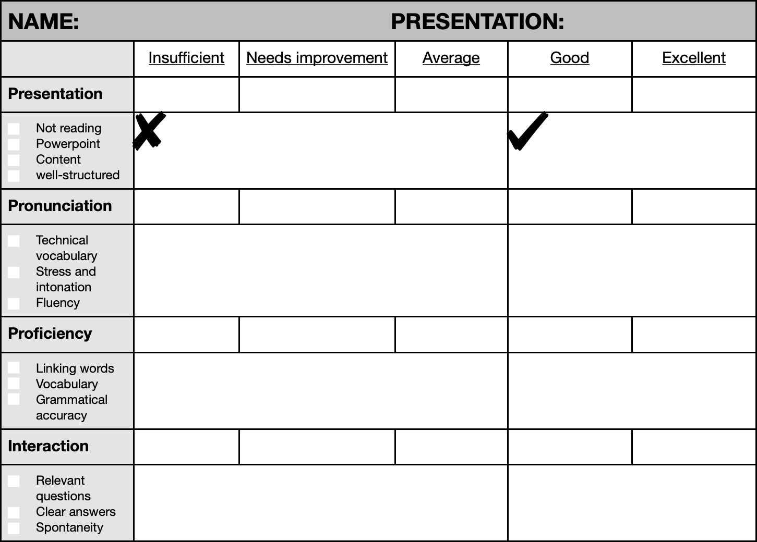

## The CEFR (The Common European Framework of Reference for Languages)

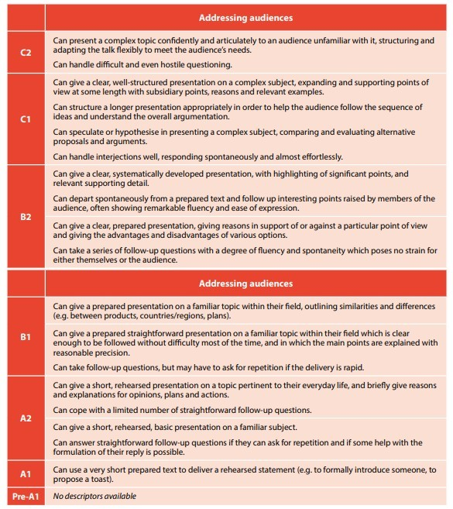

Title of the video: Date of publication:

Source: Main topic:

**OUTLINE /OVERVIEW**

1. **Main ideas of the video (sum up in a title)1**

1:

*Key words/expressions*: ……………………………………………………………………………………………………

2:

*Key words/expressions*:……………………………………………………………………………………………………

3:

*Key words/expressions*:……………………………………………………………………………………………………..

1. **Provide 2 samples of screenshots taken from the video that you'll show during your presentation.**

-Screenshot 1: Picture of the document caption: …………………………………………………….

-Screenshot 2: Picture of the document caption: …………………………………………………….

1. **The scope of the video / problems raised 2**

1-

2-

1. **Conclusion2**

-why you have chosen the video:………………………………………………………………………………………………………………………

-what you have learnt: ……………………………………………………………………………………………………………………………………..

|  |  |  |  |  |
| --- | --- | --- | --- | --- |
| Key words (video) |  |  |  | Students’ names |
| - |  |  |  | - |
| -  - |  |  |  | - |
| -  - |  |  |  | - |
| - |  |  |  | L2 Group: |

*1-the number of parts is not predetermined; it depends on your article (but not too many!) 2-in just one line; do not overload*



# Useful resources and tips

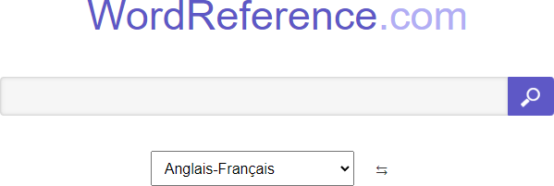

<https://www.wordreference.com/fr/>

WordReference is one of the best free dictionaries available on the Internet. It also has a very active forum that offers all kinds of help on languages.



<https://dictionary.cambridge.org/fr/dictionnaire/anglais/>

Get clear definitions and audio pronunciations of words, phrases, and idioms in British and American English from the three most popular Cambridge dictionaries of English with just one search.



<https://youglish.com/>

Use YouTube to improve your English pronunciation. With more than 100M tracks, YouGlish gives you fast, unbiased answers about how English is spoken by real people and in context.

* Don’t get discouraged if you aren’t learning English fast enough. You'll learn at your own pace!
* Don’t be afraid of making mistakes. Absolutely everyone who has ever learned a language made mistakes.
* When you come across new words, note them down, listen to their pronunciations and try to say them out loud.
* When reading a text or listening to an audio document, try to focus at first on cognates. A cognate is an easy word to remember because it looks and means the same thing as a word you already know. For example, gratitude in English means the same as gratitude in French. (It's a transparent word)
* Learning a language is communication; if you don’t talk nor write, it will be hard to improve. Reddit is a network of

communities where people can dive into their interests, hobbies and passions. There's a community for whatever you're interested in, so create an account and write comments in English!

* Change the language on your phone and favourite social media to English: it forces you to use English everyday!
* Read online newspapers, watch as many Youtube videos, movies and tv series as you can. (With or without subtitles)